Catalysis for Sustainable Development:

Recoverable homogeneous catalysts and nanocatalysis

Prof. Carmen Claver

Department of Physic Chemistry and Inorganic, University Rovira i Virgili, Centre Technologic of Chemistry CTQ, C/ Marcel•lí Domingo s/n, Tarragona, 43007, Spain.

In homogeneous catalysis with metal complexes the recovery of the catalyst is key issue for contributing to sustainable development. This presentation will describe in the first part the recycling of well-defined homogeneous catalytic systems: a) Carbene NHC-Pd complexes effectively immobilized onto silica, alumina and titania [1,2] have been used as catalysts in batch conditions for Suzuki-Miyaura and Sonogashira reactions. The NHC-Pd immobilized complexes have also been used in continuous flow conditions. High levels of conversion are obtained for both NHC-Pd systems immobilized in Al2O3 and TiO2 supports. b) Recycled Zn catalysts bearing ligands containing a pyrrolidine scaffold are applied in the coupling of CO2 with terminal and internal epoxides, providing excellent activity and total selectivity to the corresponding cyclic carbonates.[3] (Figure 1)

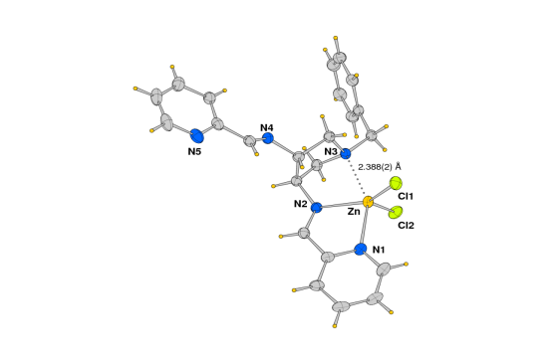



Figure 1. Homogeneous recoverable catalysts Figure 2. Rh nanoparticles for hydrogenation

The second part will focus on Rh nanoparticles for selective hydrogenation. Transition metal-nanoparticles have received a great deal of attention as catalysts since they potentially combine the advantages of heterogeneous and homogeneous catalysts. However, to date, the fine tuning of the properties of this type of catalysts to achieve specific selectivity remains a challenge. Ligands such as phosphines, phosphites and NHC-carbenes were shown to efficiently stabilize metal nanoparticles that are catalysts in the hydrogenation of various substrates.[4] To gain understanding into influence of the stabilizing ligands in catalysis, a series of Rh-nanoparticles were synthesized, characterized and their catalytic performances evaluated in the selective hydrogenation of arenes [5] and aromatic ketones.[6] (Figure 2) The results show that the nature of the ligand and steric properties clearly influence the catalytic performances of the nanocatalysts.

[1] J. Krinsky, A. Martinez , C. Godard, S. Castillon, C. Claver *Adv. Synth. Catal.,* 356 (2014) 460

[2] A. Martinez, J. Krinsky, I. Penafiel, S. Castillon, K. Loponov, A. Lapkin, C. Godard, C. Claver, *Catal. Sci. Technol.,* 5 (2015) 310

[3] Mercadé E.; Zangrando E.; Claver C.; Godard C.; *ChemCatChem,* (2015) DOI: 10.1002/cctc.201500772

[4]a) A. Gual, C. Godard, K. Philippot, B. Chaudret, A. Denicourt-Nowicki, A. Roucoux, S. Castillón , C. Claver, *ChemSusChem,* 2 (2009) 769 b) D. Gonzalez, P. Lara, O. Rivada, S. Conejero, B. Chaudret, K. Philippot P.W.N.M. van Leeuwen, *Catal. Sci. Technol.,* 3 (2013) 99

[5] J. Llop Castelbou, A. Gual, E. Mercade ́, C. Claver, C. Godard*, Catal. Sci.Technol*., 3 (2013) 2828.

[6] J. Llop Castelbou, E. Bresó-Femenia, P. Blondeau, B. Chaudret, S. Castillón, C. Claver, C. Godard *ChemCatChem*, 6 (2014) 3160